1. Input JSON file

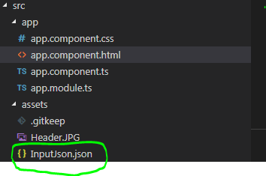

1. Headers specified In app component .ts

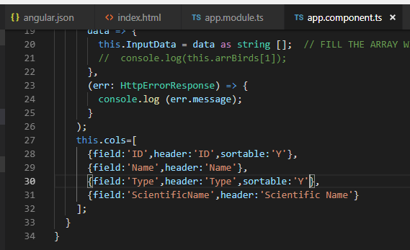

Field-whatever value is put in json

Header- display string

Sortable- makes the column sortable or not

1. Output(on page load)

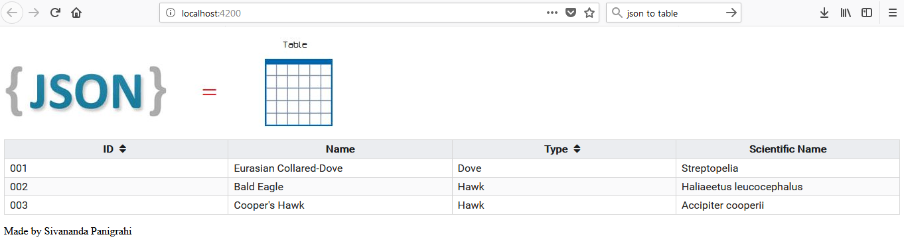

After first click on column header

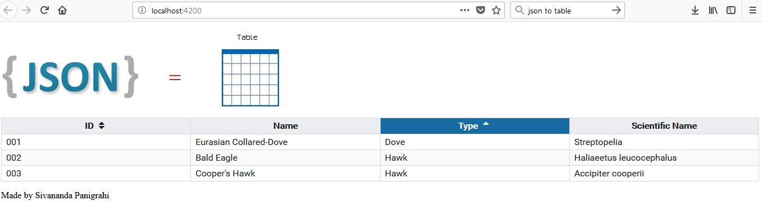

After second click on column header

